Sure! Let’s break down the self-attention mechanism with a simple example.

**Scenario**

Imagine you have a sentence: “The cat sat on the mat.” You want to understand how each word in the sentence relates to every other word. Self-attention helps in capturing these relationships.

**Step-by-Step Example**

1. **Input Representation:** Each word is represented as a vector. For simplicity, let’s use 3-dimensional vectors:
   * "The" → [1, 0, 0]
   * "cat" → [0, 1, 0]
   * "sat" → [0, 0, 1]
   * "on" → [1, 1, 0]
   * "the" → [0, 1, 1]
   * "mat" → [1, 0, 1]
2. **Create Query, Key, and Value Vectors:** For each word, you generate three vectors: Query (Q), Key (K), and Value (V). Let’s assume we have already created these vectors. Here’s a simplified version:
   * For "The":
     + Query (Q) → [0.2, 0.1, 0.3]
     + Key (K) → [0.1, 0.4, 0.2]
     + Value (V) → [0.5, 0.1, 0.3]
   * For "cat":
     + Query (Q) → [0.3, 0.2, 0.1]
     + Key (K) → [0.2, 0.3, 0.4]
     + Value (V) → [0.4, 0.5, 0.1]
   * Similarly, generate Q, K, and V for other words.
3. **Compute Attention Scores:** For each word, compute how much focus it should give to every other word using the dot product of Query and Key vectors. For example, for "The":
   * Score with "The" itself: Q("The") · K("The") = [0.2, 0.1, 0.3] · [0.1, 0.4, 0.2] = 0.02 + 0.04 + 0.06 = 0.12
   * Score with "cat": Q("The") · K("cat") = [0.2, 0.1, 0.3] · [0.2, 0.3, 0.4] = 0.04 + 0.03 + 0.12 = 0.19
   * Repeat this for all pairs of words.
4. **Normalize Scores:** Apply a softmax function to these scores to get probabilities. This step ensures the scores sum to 1 and can be interpreted as weights.
5. **Compute Weighted Sum of Value Vectors:** For each word, compute a weighted sum of all Value vectors using the attention weights.

For "The":

* + If the weights (after softmax) for "The," "cat," "sat," "on," "the," and "mat" are, respectively, [0.1, 0.3, 0.2, 0.1, 0.2, 0.1], then the new representation for "The" is:

New "The"=0.1×V("The")+0.3×V("cat")+0.2×V("sat")+0.1×V("on")+0.2×V("the")+0.1×V("mat")

Calculate this weighted sum.

**Summary**

In essence, self-attention allows each word in a sentence to focus on different words with varying degrees of importance. The result is a new representation of each word that incorporates context from the entire sentence, which helps the model understand meaning better.

This mechanism is foundational in many modern NLP models, like Transformers, and enables them to capture complex dependencies and relationships in text.

The softmax function is a mathematical tool used primarily in machine learning and statistics to convert a vector of raw scores (often called logits) into probabilities. Here's a breakdown of what it does and why it’s useful:

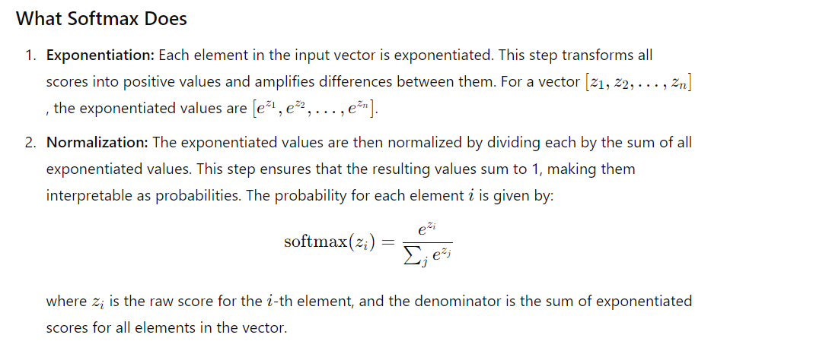

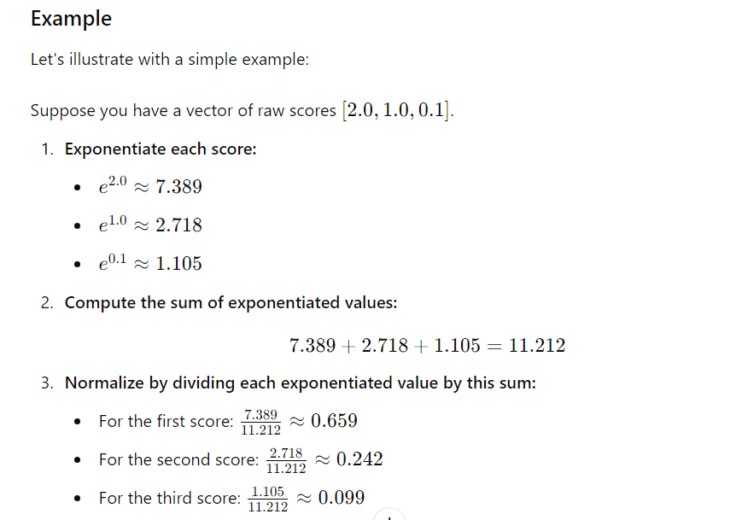

So the output probabilities are approximately [0.659,0.242,0.099][0.659, 0.242, 0.099][0.659,0.242,0.099].

### Why Use Softmax?

1. **Probability Distribution:** Softmax converts a vector of raw scores into a probability distribution, where each element is between 0 and 1, and all elements sum to 1. This is particularly useful for classification problems where you want to interpret model outputs as probabilities.
2. **Focus on Differences:** Exponentiation in softmax amplifies the differences between scores, making it more likely that the largest score will be assigned a higher probability. This can help in distinguishing between options more clearly.
3. **Gradient-Based Optimization:** Softmax is differentiable, which means it can be used in gradient-based optimization algorithms to train machine learning models. This is crucial for updating model parameters during training.

In summary, softmax is a key function in machine learning that turns raw scores into a normalized probability distribution, which is useful for making probabilistic predictions and decisions.

Certainly! Let’s go through a simple example of a feedforward neural network (FNN). A feedforward neural network is a type of artificial neural network where connections between the nodes do not form a cycle. Here’s a step-by-step illustration of a basic FNN with one hidden layer:

**Example: Predicting a Binary Output**

**Problem:** Suppose we want to create a neural network to predict whether a given input xxx belongs to class 0 or class 1 based on two features: x1 and x2​.

**Network Architecture**

* **Input Layer:** 2 neurons (for x1 and x2)
* **Hidden Layer:** 2 neurons
* **Output Layer:** 1 neuron (for the binary classification)

**Steps**

1. **Define the Architecture:**
   * Input Layer: 2 neurons
   * Hidden Layer: 2 neurons (with activation function, e.g., ReLU or sigmoid)
   * Output Layer: 1 neuron (with sigmoid activation function for binary classification)
2. **Initialize Weights and Biases:** Assume we initialize weights and biases as follows (for simplicity, let’s use small numbers):

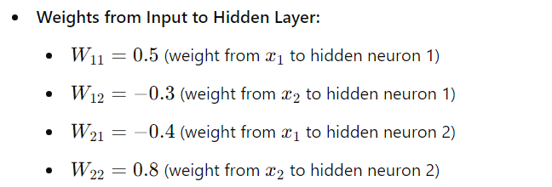

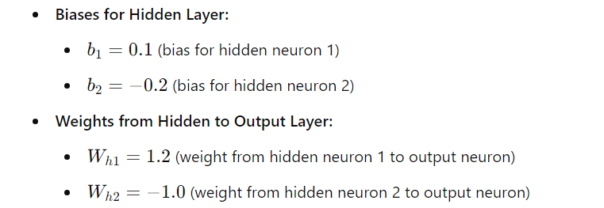

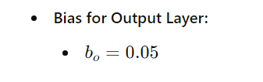

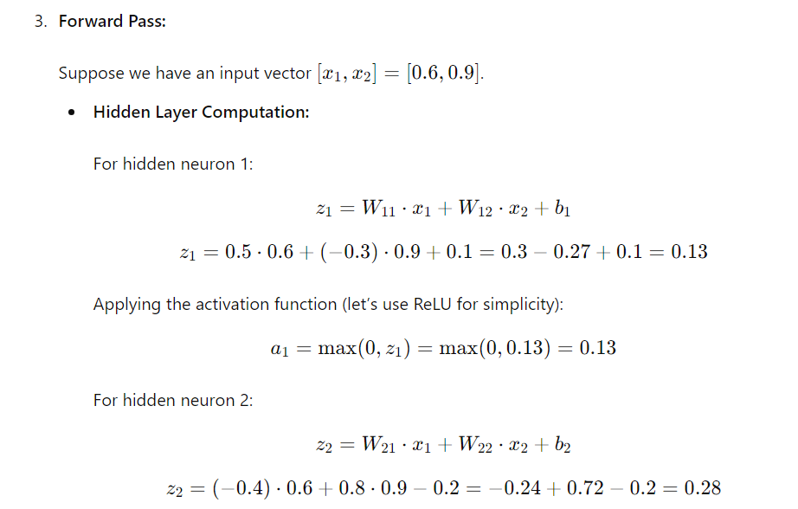

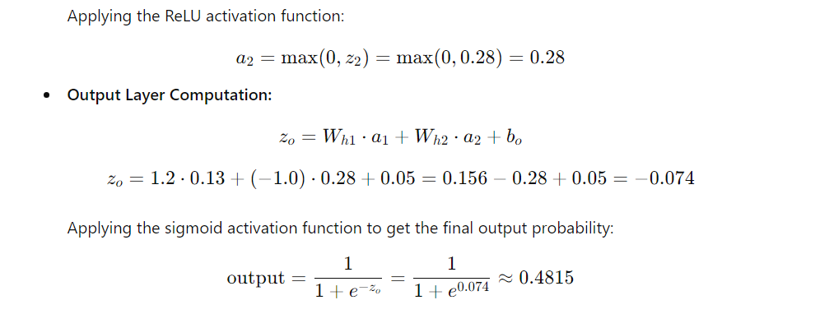

**Summary**

In this simple feedforward neural network:

* We performed a forward pass by calculating activations through hidden layers and finally producing an output.
* The network uses weights and biases to compute linear combinations of inputs, applies activation functions to introduce non-linearity, and generates a final prediction.

This example shows how inputs are processed through multiple layers to produce a prediction, which is the essence of a feedforward neural network.

Certainly! Positional encoding is a crucial concept in models like Transformers to incorporate the order of tokens (words) in a sequence, as these models themselves don’t inherently understand order.

### Context

In natural language processing tasks, the order of words in a sentence is important. For instance, “The cat sat on the mat” and “The mat sat on the cat” convey different meanings. Transformers handle tokens independently of their positions, so positional encodings are used to provide information about the position of each token in the sequence.

### Positional Encoding Example

Let’s illustrate positional encoding with a simple example. We’ll use sine and cosine functions, which is a common approach in the original Transformer paper.

### Problem

Consider a sentence with 5 words, and we want to apply positional encoding to these words.

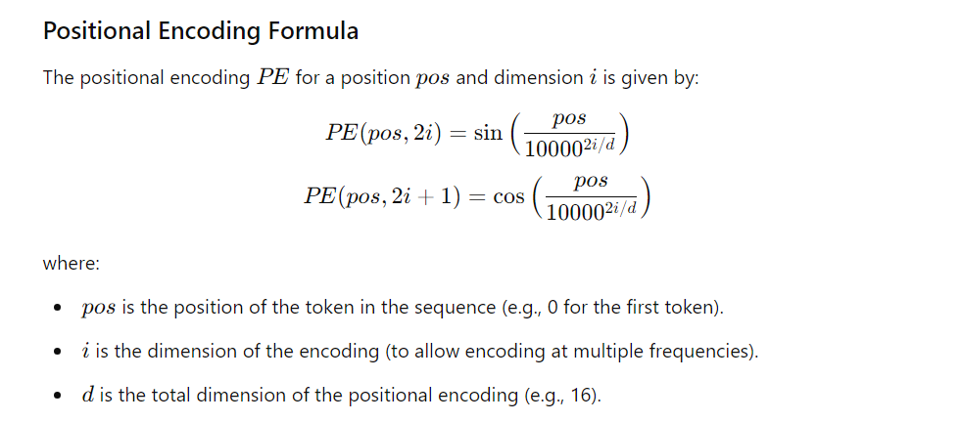

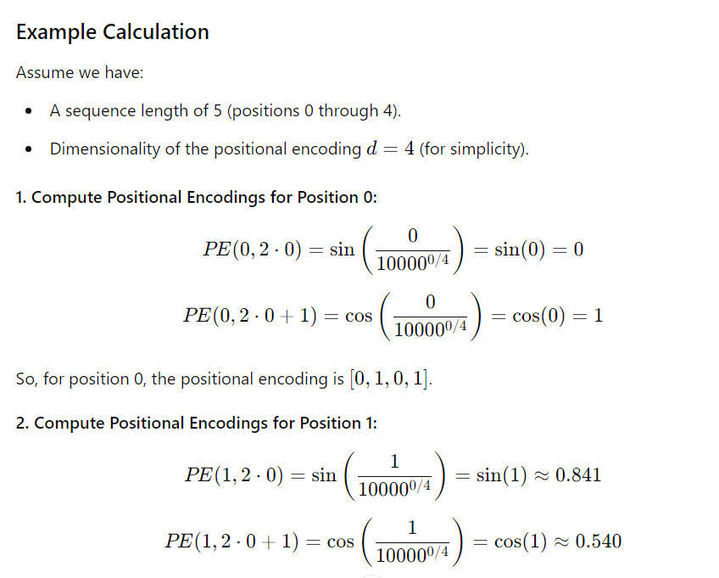

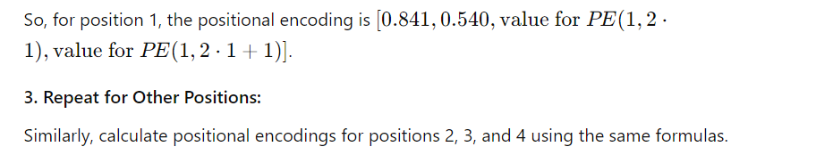

### Summary of Positional Encoding

The positional encoding vector for each position is added to the word embedding of the corresponding token. This encoding provides a way for the model to consider the order of words in the sequence, even though the Transformer architecture processes words independently.

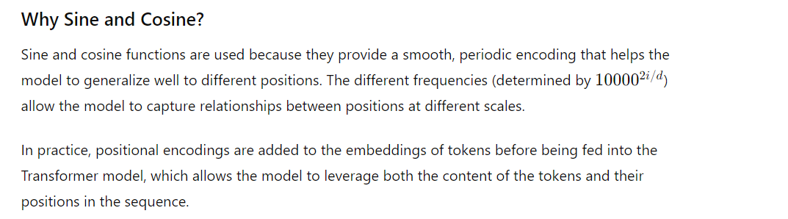

Certainly! Let's go through a small example to illustrate the concept of pre-training in machine learning, specifically focusing on natural language processing (NLP).

### Context

Pre-training is a technique where a model is initially trained on a large dataset with a general objective before being fine-tuned on a specific task. This allows the model to learn general features from the data, which can be useful for various downstream tasks.

### Example: Pre-training a Language Model

Imagine we want to create a language model that can generate text. We’ll illustrate this process with a simplified example involving two stages: pre-training and fine-tuning.

#### 1. Pre-training

**Objective:** Train a language model to understand and generate text by predicting missing words in sentences (also known as masked language modeling).

**Dataset:** A large corpus of text, such as books, articles, and websites.

**Example Sentence:** “The quick brown fox jumps over the lazy dog.”

During pre-training, we mask some words in the sentence and train the model to predict these masked words.

**Masked Sentence Example:**

* Original: “The quick brown fox jumps over the lazy dog.”
* Masked: “The quick [MASK] fox jumps over the [MASK] dog.”

**Training Task:**

* The model receives the masked sentence and learns to predict the masked words (“brown” and “lazy”) based on the context provided by the other words in the sentence.

**Training Process:**

* The model is exposed to many such sentences during pre-training, gradually learning to predict missing words and understand language patterns.

#### 2. Fine-tuning

**Objective:** Adapt the pre-trained model for a specific task, such as sentiment analysis or text classification.

**Dataset:** A smaller, task-specific dataset. For example, a dataset of movie reviews labeled with sentiments (positive or negative).

**Example Fine-tuning Dataset:**

* “I loved this movie. [Positive]”
* “The film was terrible. [Negative]”

**Fine-tuning Process:**

* The pre-trained model is further trained on this dataset to classify the sentiment of movie reviews.

**Process:**

1. **Load Pre-trained Model:** Start with the model that has already learned general language features from the pre-training stage.
2. **Add Task-Specific Layer:** Attach a new output layer tailored for sentiment classification.
3. **Train on Specific Task:** Use the movie review dataset to adjust the model’s weights for the specific task of sentiment classification.

### Why Pre-training?

* **Generalization:** Pre-training on a large, diverse dataset helps the model learn general language patterns, such as grammar and word associations, which are useful across various tasks.
* **Efficiency:** Pre-training saves time and resources because the model already has a strong understanding of language. Fine-tuning is faster and requires less data compared to training a model from scratch.
* **Performance:** Models that are pre-trained often perform better on specific tasks compared to models trained from scratch because they have a more robust understanding of language.

### Summary

In this example:

* **Pre-training** involved training a model on a large corpus to predict missing words and understand general language structure.
* **Fine-tuning** adapted the pre-trained model to perform a specific task, such as sentiment analysis on movie reviews.

This two-step approach leverages the strengths of pre-training to improve performance on specialized tasks, making it a powerful technique in machine learning.

Sure! Let’s walk through a small example to illustrate the concept of fine-tuning in machine learning, particularly in the context of natural language processing (NLP).

### Scenario

You have a pre-trained language model, such as BERT (Bidirectional Encoder Representations from Transformers), which has been trained on a large corpus of text (like books and articles) to understand general language patterns. Now, you want to adapt this model to perform a specific task, such as sentiment analysis on movie reviews.

### Steps to Fine-Tune

#### 1. Pre-trained Model

* **Pre-trained Model:** BERT
* **Purpose of Pre-training:** BERT has learned a lot about general language structure and context from a vast amount of text data.

#### 2. Task-Specific Dataset

You have a dataset of movie reviews labeled with sentiments (positive or negative). Here’s a small example:

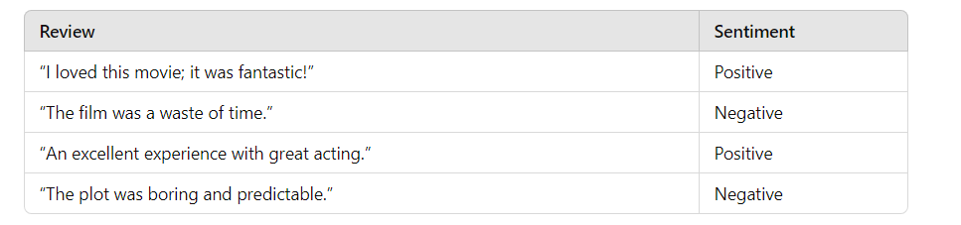

#### 3. Fine-Tuning Process

**Objective:** Adapt the pre-trained BERT model to classify movie reviews into positive or negative sentiment.

**Steps:**

1. **Load the Pre-trained Model:** Start with the pre-trained BERT model, which has general language understanding.
2. **Add a Task-Specific Layer:** Add a classification layer on top of BERT for the sentiment classification task. This layer will output two scores: one for "Positive" and one for "Negative."

Example Configuration:

* + **BERT Output Layer:** Produces embeddings based on the input text.
  + **Classification Layer:** A simple dense layer with softmax activation to output probabilities for the sentiment classes.

1. **Prepare the Data:** Convert the movie reviews into a format compatible with BERT. Typically, this involves tokenizing the text and creating attention masks.

Example Transformation:

* + Review: “I loved this movie; it was fantastic!”
  + Tokenized Input: [CLS] i loved this movie ; it was fantastic ! [SEP]
  + Attention Mask: [1, 1, 1, 1, 1, 1, 1, 1, 1, 1, 1]

1. **Train the Model:** Use the labeled dataset to fine-tune the model. During training, the classification layer learns to map BERT’s embeddings to the sentiment labels.

Example Training Process:

* + Input: Tokenized movie reviews
  + Target: Sentiment labels (Positive or Negative)
  + Loss Function: Cross-entropy loss for classification
  + Optimization: Adjust weights to minimize classification errors

1. **Evaluate and Use:** After fine-tuning, evaluate the model on a test set to ensure it performs well. You can now use the fine-tuned model to classify new movie reviews.

Example Prediction:

* + New Review: “A delightful film with a great storyline.”
  + Model Prediction: Positive (with high probability)

### Summary

In this example:

* **Pre-trained Model:** BERT, trained on general text data.
* **Fine-Tuning Task:** Sentiment classification on movie reviews.
* **Process:** Add a classification layer, prepare data, and train the model on specific sentiment data.

Fine-tuning allows the pre-trained model to specialize in a particular task, leveraging its general language understanding while adapting it to the specific requirements of the task at hand.

Sure! Let’s walk through a simple example to illustrate how reinforcement learning can be applied to fine-tune a model like ChatGPT.

**Scenario**

Suppose we want to improve ChatGPT's performance in generating helpful and engaging responses during a conversation. We use reinforcement learning to enhance the model’s responses based on user feedback.

**Example Process**

1. **Define the Task:**
   * **Objective:** Improve the quality of responses generated by ChatGPT to make them more relevant and engaging.
2. **Set Up the Environment:**
   * **Environment:** A conversational setting where ChatGPT interacts with users.
   * **Actions:** Responses generated by ChatGPT.
   * **Rewards:** Feedback scores given by users on the helpfulness and engagement of responses.
3. **Initialize the Model:** Start with a pre-trained ChatGPT model that has been trained on a large corpus of text data. This model can generate responses but needs fine-tuning to improve quality based on specific criteria.
4. **Collect User Interactions:** Deploy ChatGPT in a controlled environment where users interact with it. Each interaction consists of a user’s query and ChatGPT’s response.

**Example Interaction:**

* + **User Query:** “Can you help me plan a trip to Paris?”
  + **ChatGPT Response:** “Sure! Paris is a wonderful city. You can visit landmarks like the Eiffel Tower and Louvre Museum.”

1. **Gather Feedback:** After each response, collect feedback from users on a scale (e.g., 1 to 5) indicating how helpful and engaging the response was. This feedback serves as a reward signal.

**Example Feedback:**

* + **Response Rating:** 4/5

1. **Apply Reinforcement Learning:**

**Training with Reinforcement Learning:**

* + **Reward Signal:** The feedback rating (e.g., 4/5) serves as a reward. Higher ratings indicate better responses.
  + **Policy Update:** Use reinforcement learning algorithms (e.g., Proximal Policy Optimization or Reinforcement Learning from Human Feedback) to adjust the model’s parameters based on the reward signals. The goal is to maximize the expected reward over many interactions.

**Example Training Step:**

* + **Current Model Response:** “Paris is known for its historical landmarks.”
  + **Feedback:** 3/5
  + **Action:** Adjust model weights to improve response quality based on feedback.

**Iterate and Improve:** Continuously collect user interactions and feedback to fine-tune the model iteratively. The model learns to generate responses that are increasingly aligned with user preferences.

**Example Improved Response:**

* **User Query:** “Can you help me plan a trip to Paris?”
* **ChatGPT Response:** “Absolutely! Paris offers a lot. You might enjoy a visit to the Eiffel Tower, a walk along the Seine, and a day exploring the Louvre. Let me know if you need tips on accommodations or restaurants.”

**Feedback:** 5/5

1. **Deploy and Monitor:** Once fine-tuned, deploy the updated model and monitor its performance in real-world interactions. Continue to gather feedback and refine the model as needed.

**Summary**

In this example:

* **Task:** Improve ChatGPT’s responses to be more helpful and engaging.
* **Environment:** Conversational interactions with users.
* **Feedback:** User ratings for response quality.
* **Reinforcement Learning:** Used to adjust the model based on feedback to enhance performance.

Reinforcement learning in this context helps fine-tune ChatGPT to generate better responses by learning from user interactions and feedback, ultimately making the model more effective in providing useful and engaging conversations.

Certainly! The Transformer architecture is a foundational model in natural language processing (NLP) introduced by Vaswani et al. in the paper *"Attention is All You Need"* (2017). It has become the basis for many state-of-the-art models like BERT, GPT, and T5.

Here’s a breakdown of the key components and structure of the Transformer architecture:

**1. Overview of the Transformer Architecture**

The Transformer architecture consists of an **encoder** and a **decoder**, each comprising multiple layers of attention and feed-forward components. It operates entirely through attention mechanisms and does not rely on recurrent neural networks (RNNs) or convolutional networks.

**2. Encoder**

The encoder processes the input sequence and generates a set of encoded representations.

**Components of the Encoder:**

1. **Input Embedding:**
   * Converts input tokens into dense vectors.
   * Includes **positional encoding** to add information about the position of tokens in the sequence.
2. **Self-Attention Mechanism:**
   * Allows each token to focus on other tokens in the input sequence.
   * **Scaled Dot-Product Attention:** Computes attention scores using dot products, scales them, applies softmax, and uses the result to weight the value vectors.

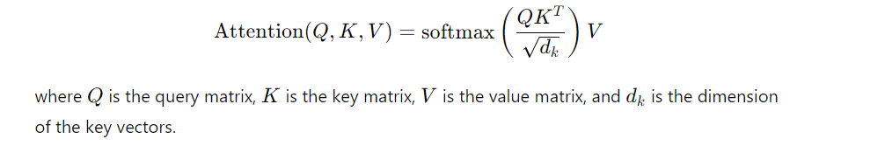

1. **Multi-Head Attention:**
   * Applies multiple self-attention mechanisms in parallel to capture different types of relationships between tokens.
   * Concatenates the outputs of each head and projects them through a linear layer.
2. **Feed-Forward Neural Network:**
   * Applies a position-wise feed-forward network to each position separately.
   * Typically consists of two linear transformations with a ReLU activation in between.
3. **Add & Norm:**
   * Applies residual connections around the self-attention and feed-forward layers followed by layer normalization.

**Encoder Layer Structure:**

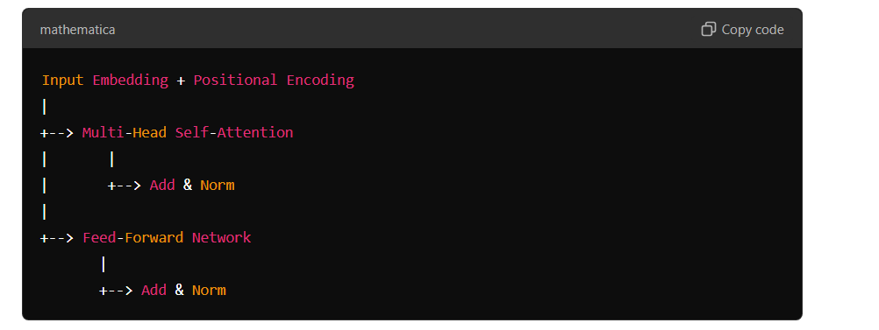

**Decoder**

The decoder generates the output sequence based on the encoded input and previously generated tokens.

**Components of the Decoder:**

1. **Output Embedding:**
   * Converts output tokens into dense vectors, similar to input embeddings.
2. **Masked Multi-Head Self-Attention:**
   * Ensures that each position can only attend to earlier positions in the sequence (preventing future tokens from being seen).
3. **Encoder-Decoder Attention:**
   * Allows the decoder to focus on relevant parts of the input sequence using attention mechanisms applied to the encoder’s output.
4. **Feed-Forward Neural Network:**
   * Same as in the encoder, applied to each position.
5. **Add & Norm:**
   * Residual connections and layer normalization are applied similarly to the encoder.

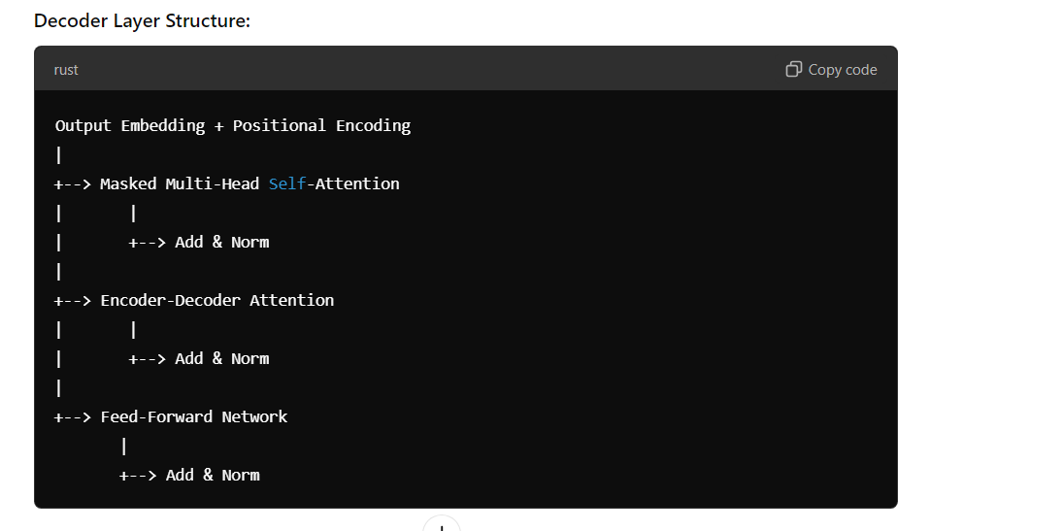

**Overall Architecture**

1. **Stack of Encoders:**
   * Multiple layers of the encoder are stacked to capture complex patterns in the input.
2. **Stack of Decoders:**
   * Multiple layers of the decoder are stacked to generate the output sequence.
3. **Final Linear Layer and Softmax:**
   * The output of the top decoder layer is passed through a linear layer followed by a softmax function to produce probability distributions over the vocabulary for the next token in the sequence.

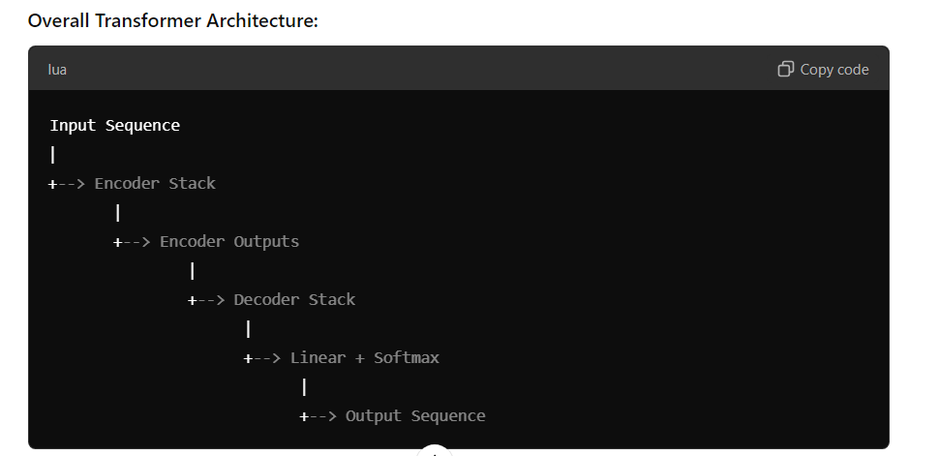

**Summary**

* **Encoder:** Transforms input tokens into encoded representations using self-attention and feed-forward layers.
* **Decoder:** Generates output tokens by attending to encoded representations and previously generated tokens.
* **Attention Mechanism:** Allows the model to weigh the importance of different tokens, capturing dependencies and relationships effectively.

The Transformer architecture's ability to handle long-range dependencies and parallelize computations has made it highly successful in various NLP tasks and has influenced many subsequent models in the field.